**Issue Report of My deal**

1. <http://mydeal.acumencs.com/coupons> in this page showing 404 errors.
2. Forgot password functionality not working.
3. “Top deals”, “Daily deals”, “Popular Deals” button has no link, if user click from this URL <http://mydeal.acumencs.com/store.html>.
4. In the feedback section name field is taking special character.
5. There is a symbol which should remove from the footer section. See the screenshot:

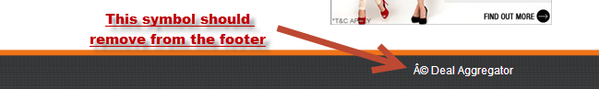

1. In admin section from where admin can see the feedback messages?